HADLEY, MICHAEL

Teesside University  [Company address]

Final Year Project Report

Contents

References: 2

Games assets:

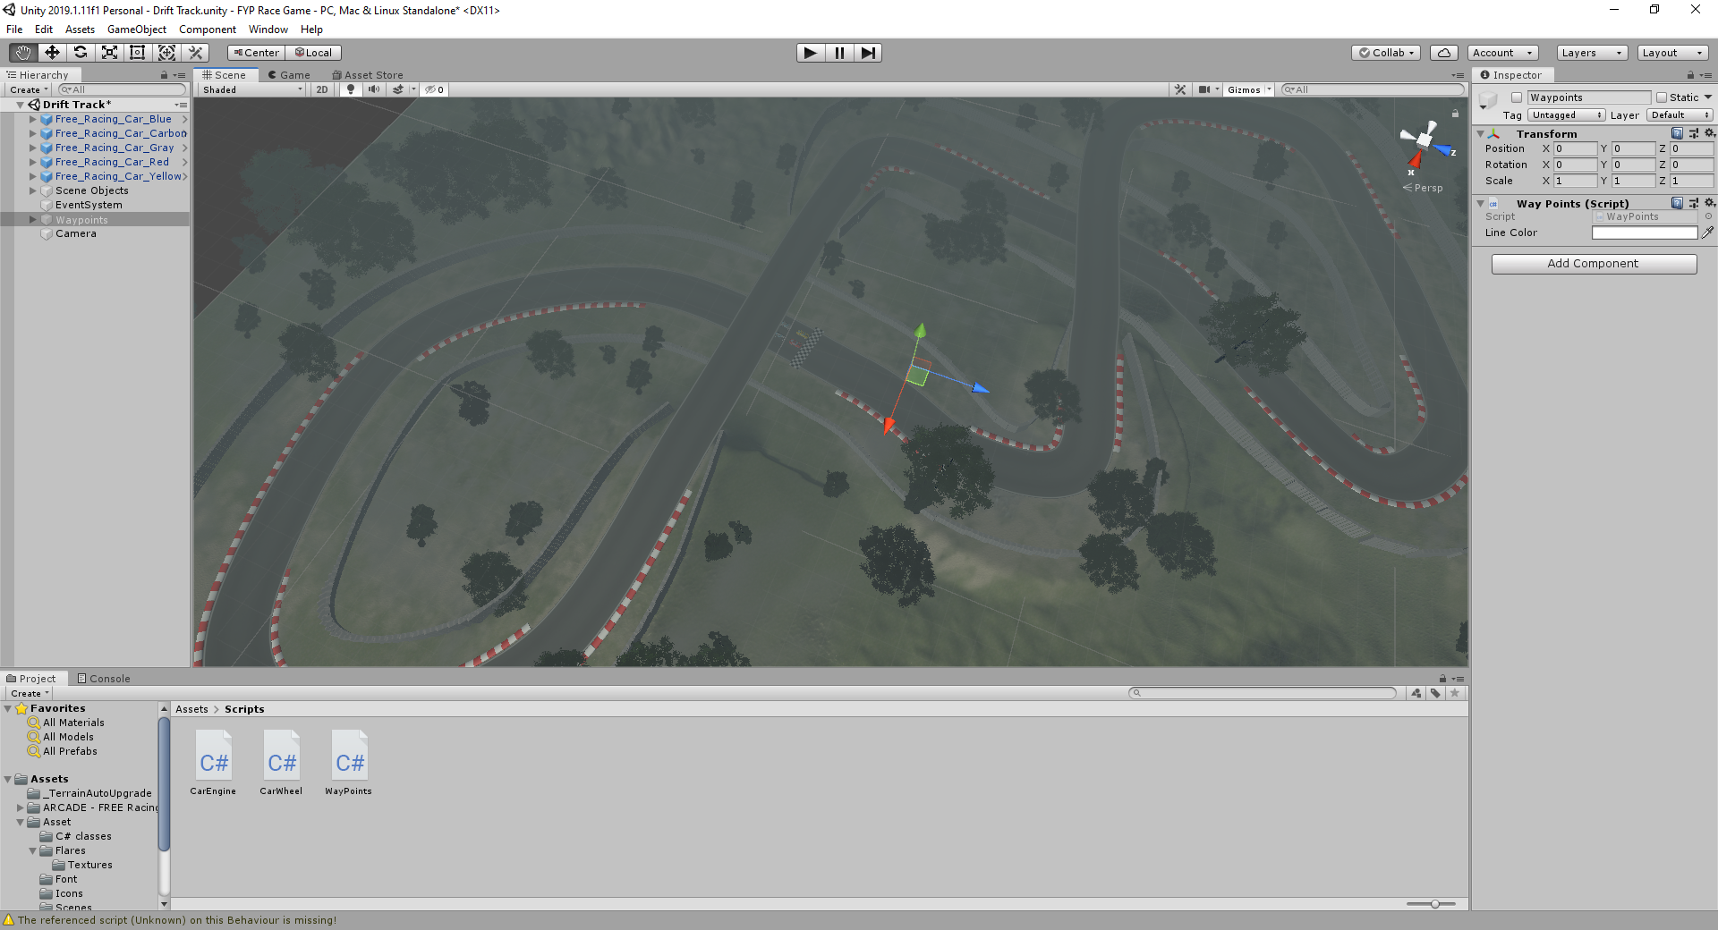

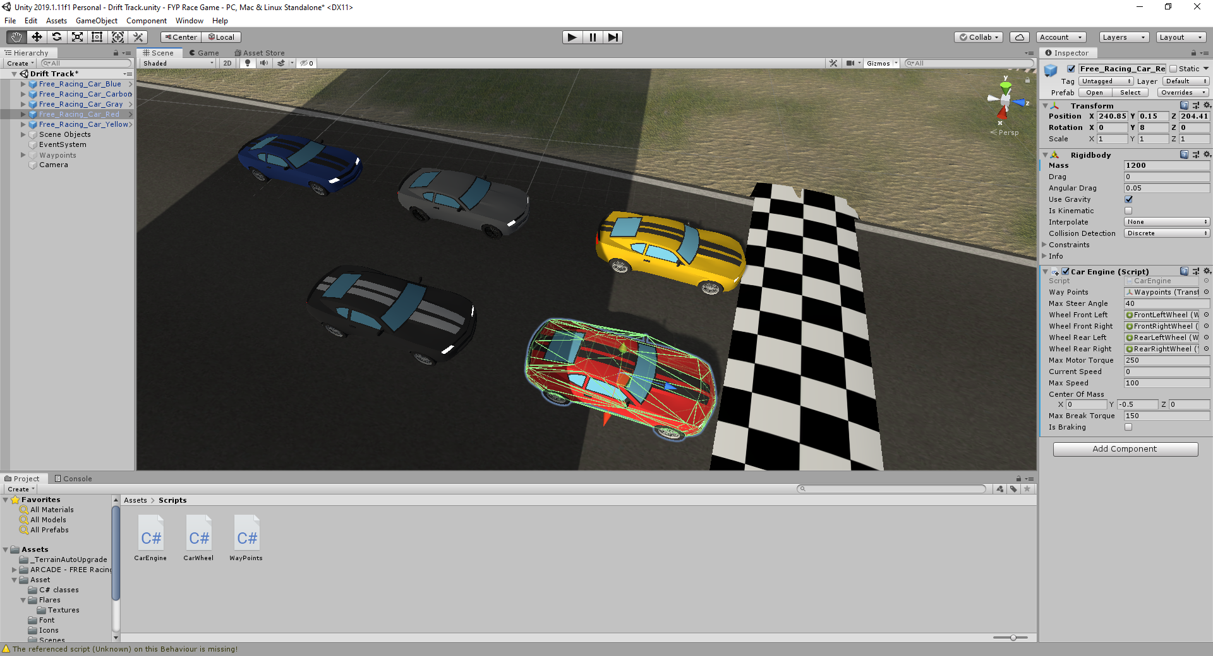

Created the waypoints for the AI cars to follow. Thursday 5th March 2020

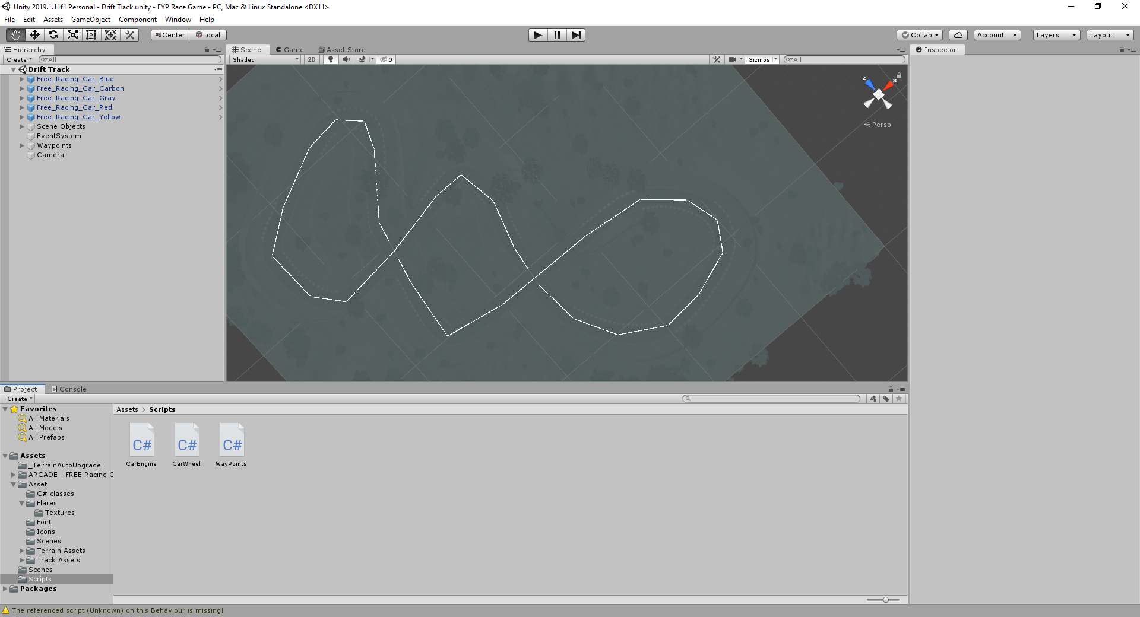

Wheel colliders Sunday 8th March 2020. So that the car turn and drive around the map.

Monday 9th March: Implemented the code to allow the cars to drive to the nearest checkpoint but the cars cannot complete a full lap as they drive off the track and crash.

13th March the AI cars can now complete a lap but they still crash into each other.

26th March the AI cars can now break making the laps more consistent.

2nd April created a car controller class to allow one the cars to be controlled manually. The car turn, brake and accelerate.

3rd April implanted a speedometer to view the players speed. Created a new camera class so that the player’s car can viewed from two different camera angles.

8th April changed the start finish line to a flag and poles that the cars drive under instead of a checkered floor that they drove over. I then put a trigger under the new start finish line position so that when the cars went through they could set a lap time that would be made later on. This was coupled with a second trigger which I placed at the half point of the track so that when the cars drove through that the starting trigger would reset allowing the car to complete a full lap once they went past the start finish line a second time.

10th April created a lap timer to use the triggers previously made to start a current lap and to set a best lap once crossing the finish line.

15th April implemented a countdown at the start of the race so that the game would start 3, 2, 1 then all the cars can go. I created a 60 second animation so that the numbers would rotate of the screen to reveal the next number in the countdown. Created a cars manager script that would allow activate all the car scripts once the countdown finished allowing the AI cars to drive and the player to drive. I turned off the AI car engine script and the Car Controller script so that when the game is played they cannot move until the start timer has finished.

The demo video show cases the current state of the project at the start of the race.



# References:

<https://assetstore.unity.com/packages/3d/environments/roadways/race-tracks-140501>

Author: Abdul Rahim

Asset Pack: Race Tracks

Accessed 06/02/2020

<https://assetstore.unity.com/packages/3d/vehicles/land/arcade-free-racing-car-161085>

Author: iMENA Games

Asset Pack: Arcade: Free Racing Car

Accessed 06/02/20